
ОБЩЕСТВО С ОГРАНИЧЕННОЙ ОТВЕТСТВЕННОСТЬЮ
«ЛАЗЕРТАГ»

ПАСПОРТ

Смоленск
LIMITED LIABILITY COMPANY
LASERWAR

SPECIFICATION

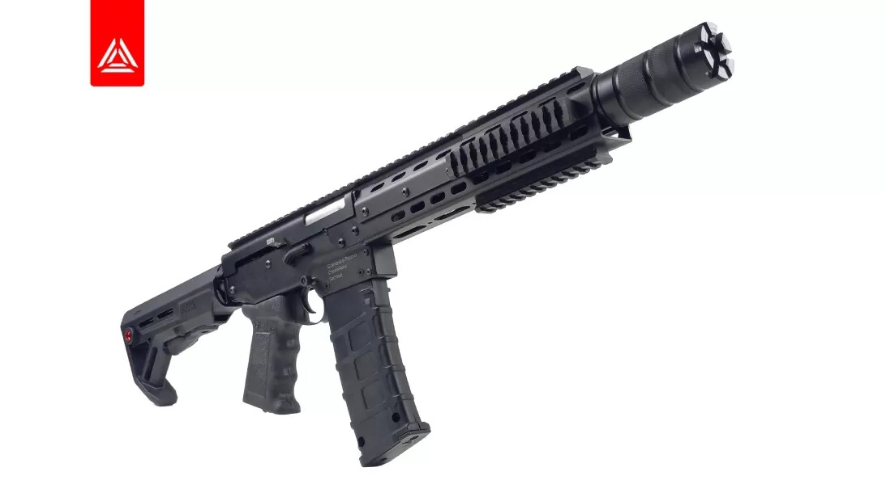

AR-23 « barracuda »
play set SPECIAL edition
Alphatag platform

Dear Customer!

Our company welcomes and thanks you for the decision to buy our products, and is confident that the purchased device will bring you a long-term pleasure. The warranty certificate establishes the guarantee of the product in the amount provided for by the Law on consumer protection of the Russian Federation.
This warranty certificate is valid for 24 months from the purchase date of the product, provided the guarantee terms are observed.

- Contact information
Official website:
www.laserwar.com

E-mail:
info@laserwar.com
help@laserwar.com

Skype:
info@laserwar.com
help@laserwar.com

_____________________
signature

Equipment version: Serial Number:

v.11 ALFA TAG

2
11

Purchase Date: _______________
- The intent of the device
The AR-23 « barracuda » play set SPECIAL edition game set is a sound-and-light rifle designed to play laser tag.

- Technical Specifications
Weight | 3.4 kg
Length | 107 cm
Battery type | Li +;  7.4 V; 2200 mAh
Battery charger Type | automatic, Li +
Battery life | up to 30 h
Range of fire | 185 m
Software programs | LASERTAG-configurator

- Contents of delivery
№  Ser. No. | Name | Unit of Measure | Quantity
1. | Sound-and-light rifle | pc. | 1
2. | Specification | pc. | 1

Information on the repairs performed during the maintenance period (completed by the Service centre performing the warranty repair works).

Date: __________________  Completed work: _____________________________________________________________________  Service centre stamp | Date: __________________  Completed work: _____________________________________________________________________  Service centre stamp
Date: __________________  Completed work: _____________________________________________________________________  Service centre stamp | Date: __________________  Completed work: _____________________________________________________________________  Service centre stamp
Date: __________________  Completed work: _____________________________________________________________________  Service centre stamp | Date: __________________  Completed work: _____________________________________________________________________  Service centre stamp

3
10
- Description and work
  - Device
The AR-23 «barracuda» play set SPECIAL edition game set consists of two parts: a sound-and-light rifle and a headband with hit sensors.
The connection between the weapon and rifle is affected with the help of Bluetooth technology.
The AR-23 «barracuda» play set SPECIAL edition game set is shown on the Diagram No. 1.

Diagram No. 1

1 – buttstock (not collapsible).
2 – safety catch.
3 – bolt for reloading.
4 – optical system.
5 – anti-vandal power lock
6 – power socket.

Guarantee terms and conditions:
1. The guarantee comes into force upon presenting of this slip, with a confirmed by a repair center date of purchase displayed.
2. These guarantee promises cover only the devices purchased from an official representative of LLC LASERWAR, or its official dealer.
3. This guarantee does not cover products in the following cases:
- if the customer does not follow the directions outlined in the User’s manual;
- in case of damage;
- if any objects or liquids get inside of the device.;
- if it gets damaged by pets;
- unauthorized access to the units and details of the device;
- abuse or misuse, including failure to use this product for its normal purposes;
- any cause beyond the control of the company, Force Majeure (natural catastrophes, fire, accidents, etc.);
- if the device fails due to incorrect connection, voltage fluctuations, and/or improper care.
4. Should it happen that you loose your guarantee slip, you will not be issued a copy.

4
9
  - Changing the performance characteristics

The tactical and technical characteristics of the device can be changed by using the uniform settings program “ALPHATAG-configurator”, which is presented in Picture 1
Picture 1
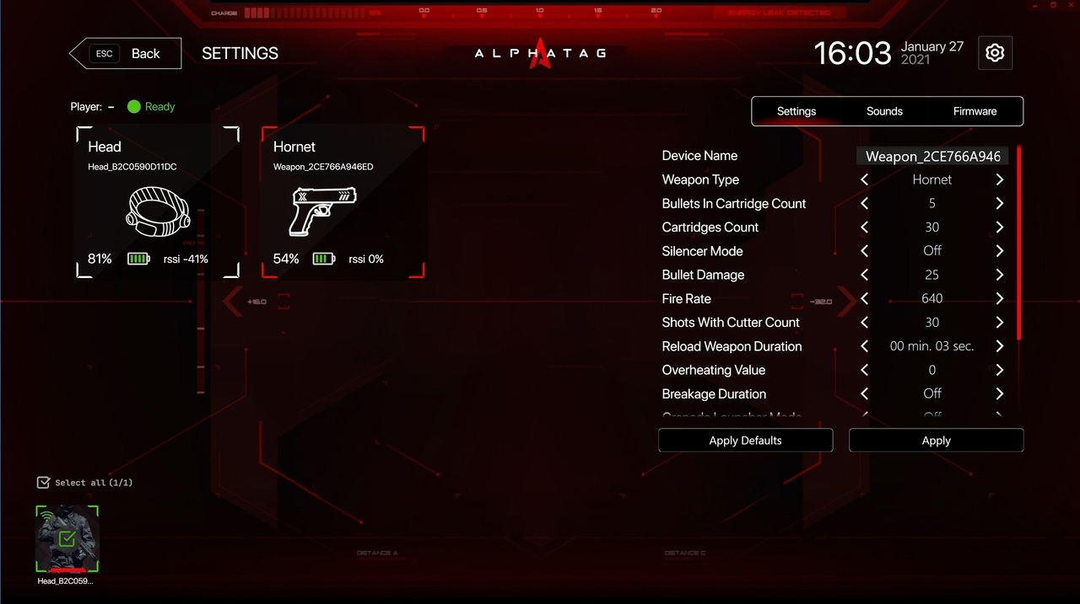
Turn on the headband and rifle and hold them close to each other to establish a connection. In the main window of the configurator, select the "Settings" mode, and the window that opens will display the active connection and the number of connected devices.
Select the desired device, adjust its parameters and click the "Apply" button. Under the device icons, the battery charge and Wi-Fi signal levels are displayed.

In addition, during use of headbands, the device can experience mechanical damage to the caps that protect the sensors. In such cases, the caps must be replaced. It is necessary to recharge headbands immediately, no longer than 80 minutes after the game.
It is necessary to store the equipment in a well-ventilated space at temperature from + 18°C to + 30°C and relative humidity of 45-65%.
Store equipment only in charged state (ideally under nominal voltage conditions).

- Guarantee commitment
The manufacturer guarantees reliability of the LASERWAR individual set provided the user complies with all the product use requirements. The manufacturer promises to replace or repair an individual set of equipment provided that the user complied with the rules of transportation, storage, use and paid for the delivery of the faulty equipment to the city of Smolensk.
The guarantee cover for battery chargers, speakers, infrared modules is 14 DAYS.
ATTENTION! If the battery is used incorrectly (wrong battery charger is used to charge the equipment), the accumulators will not be covered by the guarantee!

Visit our website www.laserwar.com to read the full version of the user’s manual by LLC LASERWAR.

5
8
6
7
Choose the required game set by ticking the appropriate box. Press the "Write" button. Having confirmed the changes, restart the game set.

  - Pre-starting procedure
To activate the AR-23 « barracuda » play set SPECIAL edition game set turn on the weapon and headband. Having connected the headband and weapon will enter the standby mode. The diodes will start blinking frequently. Then run the "New game" command using a remote control.
The device is ready to use.

- Operating rules
1. Weather conditions. We strongly recommend that the equipment shouldn't be used in the rain and at temperatures below -20 °C.
Avoid getting moisture inside the device. If this happened, turn off the device, dry the equipment at room temperature for at least two hours.
Having used the device at low temperatures don't try to charge it immediately after the game. Wait for electronics to warm up.
2. Batteries. The device from the "STEEL" series has lithium batteries. To recharge the device use only universal Li+ chargers.
Connect the charger to the device, and only then to the network.
You can control the recharge process with the help of a special indicator. If the battery is low, the LED is red; When the recharge process is complete, the color will be changed to green.
Please note! The game set must be recharged immediately after you have played with it under constant supervision at temperature no less than 0°С and no longer than for 2 hours.
3. Headband When using headbands pay attention to hygienic cuffs. They will protect electronic parts from moisture. If the bandage gets wet, it can result in the electronics failure. That's why the bandage should be dried.

